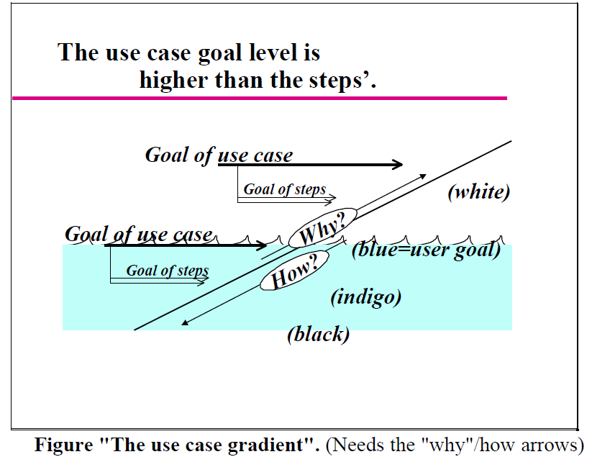

User story 60420 : Compare SmartSalary Business Leader with SmartSalary RSZ Employee
- No confluence page yet, but an Excel file with the summary.
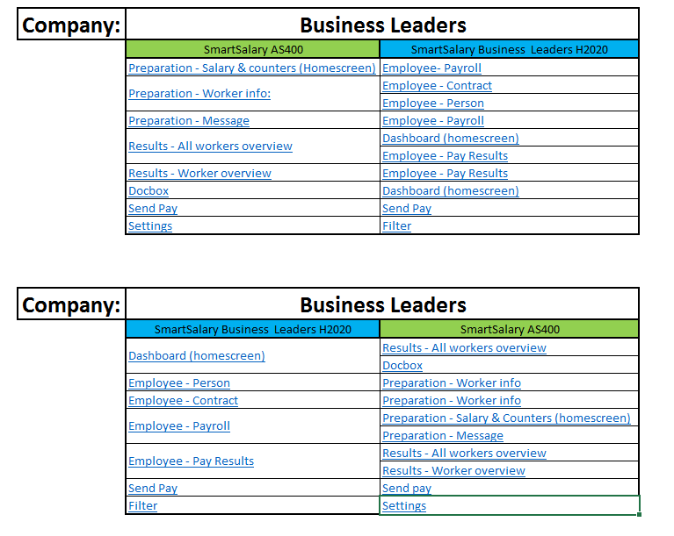

User story 58652: Wizard Add Business Leader (3 Steps)
- Confluence Page: https://partena.atlassian.net/wiki/x/E4TZJw

User story xxxxx: Confirm Initiate Add Employee (Ok, let’s start)
- Confluence Page: https://partena.atlassian.net/wiki/spaces/HPROJ/pages/680264801/Confirm+Initiate+Add+Employee

User Story 51302 + 58494: Initiate Add Employee (Steps before Add Employee / Business Leader Wizard)
- 51302: HTML: https://partena.atlassian.net/wiki/x/EYHEJw
- 58494: Full functional: https://partena.atlassian.net/wiki/x/UoqaJw

User story 60780: Input National number
- Confluence page: https://partena.atlassian.net/wiki/x/OYHNK

User Story 58500: INSS Input and Validator
- Confluence page: https://partena.atlassian.net/wiki/x/nQDGJw

User Story 60771: Proposal UX Lib Textbox
- Confluence page: https://partena.atlassian.net/wiki/x/AImuK

User story 60920: Input Active Pensioner
- Confluence page: https://partena.atlassian.net/wiki/x/rwHDK

User story xxxxx: Input checkbox
- Confluence page: https://partena.atlassian.net/wiki/x/OYHNK

Add Employee (High level)
